CTL DECISION SHEET (PDSH)

Standard(s) (incl. year) | Subclause(s) | No. | Year
IEC 60950-1:2005/A1 | 2.10.5.12 | DSH  1031 | 2012
Category | 2.10.5.12 | DSH  1031 | 2012
OFF | 2.10.5.12 | DSH  1031 | 2012
Subject | Keywords | Developed by | Approved at
Crossing of triple insulated winding wire | -Triple insulated wire  - Mechanical stress relief  - Physical separation | ETF2 | 2012 CTL Plenary Meeting
Question
Transformers in switching mode power supplies often contain triple insulated winding wire (=TIW) (wire with extruded insulation layers). These windings typically cross each other at an angle between 45° and 90° at the exit points as marked in the Figure below.

In the given example TIW is used for secondary circuit windings, whereas the primary circuit windings are made of enamel coated wire. Distances between the point where TIW crosses itself and primary circuit winding wire do not comply with Basic (respectively Supplementary) Insulation requirements.

Is it necessary in the given design to provide either mechanical stress relief at the crossing point(s) of TIW, or an additional insulation level (e.g., Basic (Supplementary)) between the crossing point(s) of TIW and primary circuit parts (winding)?
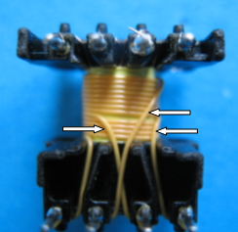

Decision
No
Explanatory notes
In the given example, a secondary winding of TIW (triple insulated wire) is used that is suitable for reinforced insulation between the secondary and primary windings.Although the cross-over point is Functional Insulation, there are six (6) layers of insulation at the crossing point, which is considered an adequate mechanical protection mentioned above. Therefore, even if the mechanical stress is applied to the crossing point, in the context of the requirement, the insulation on the TIW will provide adequate protection, and therefore, damage resulting in an exposure of secondary winding conductor is considered unlikely. This construction is considered to meet the intent of the last sentence of 2.10.5.12.

